***Biology notes:***

***Topic 1 – Cell Biology:***

**Cells:**

All living things are made of cells

* Cells can either be prokaryotic or eukaryotic
  + Eukaryotic Cells
    - Complex
      * E.g. Animal and plant cells
    - Eukaryotes are organisms that are made up of eukaryotic cells
  + Prokaryotic cells
    - Small and simple
      * E.g. Bacteria

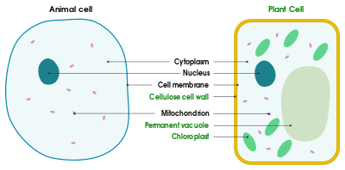

* + - A prokaryote is a prokaryotic cell (a single celled organism)
* Animal Cells:
  + Most animal cells have the following subcellular structures:
    - Nucleus
      * Contains genetic material that controls the activities of the cell
    - Cytoplasm
      * Gel-like substance where most of the chemical reactions happen
      * It contains enzymes that control these chemical reactions
    - Cell Membrane
      * Holds the cell together and controls what goes in and out of the cell
    - Mitochondria
      * Where most of the reactions for aerobic respiration occur
      * Respiration transfers energy that the cell needs to work
    - Ribosomes
      * Where protein is made
* Plant Cells:
  + Usually have all the subcellular structures that animal cells have plus:
    - Rigid Cell Wall
      * Made of cellulose
      * It supports and strengthens the cell
    - Permanent vacuole
      * Contains cell sap, a weak solution of sugar and salts
    - Chloroplasts
      * Where photosynthesis occurs, which makes food for the plant
      * They contain a green substance called chlorophyll which absorbs light
* Bacteria Cells:
  + Bacteria are prokaryotes

**Microscopy:**

* Microscopes let us see things that we can’t see with the naked eye
* The microscopy techniques we can use have developed over the years as technology and knowledge have improved
* Light microscopes:
  + Light microscopes use light and lenses to form an image of a specimen and magnify it
* Electron microscopes
  + Use electrons instead of light to form an image
    - They have a much higher magnification than light microscopes
    - They also have a higher resolution
  + This means that they let us see much smaller things in more detail
* Magnification = image size / real size